Honeywell Voyager XP 1470g
USB-COM-Modus
07.05.2025
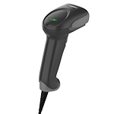
Reset the Custom Defaults | Activate Custom Defaults | DEFALT
Beeper Volume - Good Read | Low | BEPLVL1
Plug and Play Codes: USB | USB Serial | TRMUSB130
Cellular Telephone Reading Mode | On | DECCEL1
Prefix: STX | PREBK29902
Suffix: ETX | SUFBK29903


DEFALT;BEPLVL1;TRMUSB130;HSTACH18;HSTDCH20;DECCEL1;PREBK29902;SUFBK29903.

